Automatic Solar Lighting System

Bakanyildiz, Atahan;

Gilat, Romi;

Maxwell, Cedar;

Miller, Nick

**Concept of Operations**

REVISION – 1

15 September 202

Concept of Operations

for

Automatic Solar Lighting System

Team <04>

Approved by:

_____________________________

Project Leader Date

_____________________________

Prof. Lusher Date

_____________________________

T/A Date

**Change Record**

| **Rev.** | **Date** | **Originator** | **Approvals** | **Description** |
| --- | --- | --- | --- | --- |
| **0** | 09/10/2024 | Automatic Solar Lighting System |  | Draft Release |
| **1** | 09/15/2024 | Automatic Solar Lighting System |  | Revision 1 |

**Table of Contents**

**List of Figures** **4**

**1. Executive Summary** **5**

**2. Introduction** **5**

2.1 Background 5

2.2 Overview 6

2.3 Referenced Documents and Standards 6

**3. Operating Concept** **7**

3.1 Scope 7

3.2 Operational Description and Constraints 7

3.3 System Description 8

3.4 Modes of Operations 10

3.5 Users 10

3.6 Support 10

**4. Scenarios 1****1**

4.1 Rolling Blackouts 11

4.2 General Use-Case 11

**5. Analysis 1****1**

5.1 Summary of Proposed Improvements 11

5.2 Disadvantages and Limitations 11

5.3 Alternatives 12

5.4 Impact 12

## List of Figures

Figure 1: Automatic Solar Lighting System Block Diagram……………………..…………6

Figure 2: Pulse Width Modulation..…………………………………………………………...………8

Figure 3: Microcontroller……………………………………………………...……..……………………9

Figure 4: Ambient light sensor………………………………………………...…….……………….…9

Figure 5: Passive Infrared……………………………………………..…………………………………..9

Figure 6: Buck Converter……….………………………………………………...…………………………….9

Figure 7: Mobile App Icon………….……………………………………….……………………….………..10

# 

# Executive Summary

The Automatic Solar Lighting System (the “System”) provides an elegant solution to your indoor and outdoor lighting needs. Using motion sensors for your home’s interior and ambient light sensors for your porch, the System automatically raises and lowers the lights when appropriate; no effort required. Accompanying this is an app which provides for manual operation of the System as well as various statistics pertinent to the System’s usage and operation. The power of the sun allows the System to operate independently during the day, all while charging a battery to allow continuous operation throughout the night. The System utilizes solar power, which does not raise your utility bill, on the contrary, it lowers it. This system operates completely independently of your current grid controlled home electric system. It is a model for what the future may look like as photovoltaic technology continues to rapidly develop, if the past two decades are any indication.

# Introduction

The Automatic Solar Lighting System is a power efficient interior and exterior lighting system powered by solar panels with integrated motion sensors for automated light controls and app based controls center. This system is an efficient way to light up the exterior and interior of a house using solar panels, with an interactive app that will give statistical data for the overall system. The Automatic Solar Lighting System will enhance your home’s lighting system by replacing the manual indoor and outdoor lighting system while being powered by the solar panels.

## 2.1 Background

Automatic lighting systems are a newer concept, only being put into homes around the early 2000s. The age of smart lighting systems included the integration of microcontrollers and sensors, which allowed lighting systems to “sense” its environment and make decisions based on pre-determined code. The use of “smart lighting” exploded in 2012, with the Philip Hue having advanced features such as motion detection, voice control and app integration.

Although smart lighting has been integrated into the daily lives of homeowners in the past decade, solar panels have been used as the primary power source for individual residential units since the 1970s. The increased adoption of solar panels has been directly correlated with depreciating costs. In the early 2000s, federal tax incentives boosted the use of solar panels, incentivising their purchase through tax subsidization. As their popularity continued to grow, the U.S. government introduced programs that allowed homeowners to sell excess electricity back to the grid.

Now, with the steep increase in both environmentally friendly energy sources like solar panels and rise of smart homes has allowed for technology like the Automated Solar Lighting System to be easily implemented in residential or commercial builds. This system combines the customization of technology for ease with eco-friendly energy efficient power sources. This allows homeowners to substantially reduce their taxes and energy consumption from the grid without compromising on the high tech lifestyle seen in movies.

## 2.2 Overview

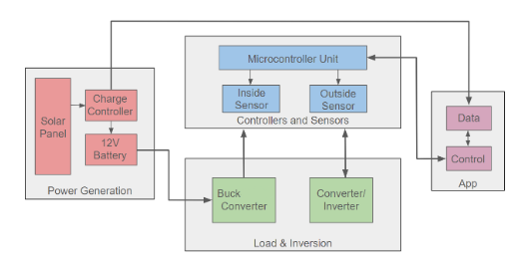

Figure 1: Automatic Solar Lighting System Block Diagram

This system will be completely solar powered via the use of a solar panel which through the use of a charge controller, will charge a 12V lead-acid battery. This charge controller will additionally provide battery charge and solar panel charge efficiency data to the application. The 12V battery will go through a buck converter to have the correct DC voltage for use of the Microcontroller Unit (MCU) and the Ambient and Infrared sensors utilized in the controls and sensors section. The MCU will communicate with other microcontrollers in each of the outside and inside sensor systems and the information given by the sensors to turn on and off given the time of day and presence of people near the lights. Between the controllers and lightbulbs of the respective inside and outside sensors will be inverters and converters to utilize AC powered light bulbs, which are much more common. The app, additionally to providing data about the power generation of the system, will communicate with the MCU in order to allow for on/off control and automation toggling.

## 2.3 Referenced Documents and Standards

[1] IEEE Wi-Fi communication standards: IEEE 802.11

[2] IEEE Bluetooth communication standards: IEEE 802.15

[3] IEEE P3326-2021 - IEEE Standard for Performance and Functional Requirements of Passive Infrared (PIR) Sensors for Surveillance and Security Systems.

[4] IEEE SCC21 - IEEE 1562-2021 – *IEEE Guide for Array and Battery Sizing in Stand-Alone Photovoltaic (PV) Systems*. New York, NY: IEEE, 2007. doi: 10.1109/IEEESTD.2007.4285832.

[5] IEEE SCC21 - IEEE 1661-2019 – *IEEE Guide for Test and Evaluation of Lead-Acid Batteries Used in Photovoltaic (PV) Hybrid Power Systems*. New York, NY: IEEE, 2007. doi: 10.1109/IEEESTD.2007.4285867

# Operating Concept

## 3.1 Scope

The automatic solar lighting system will provide a clean energy, energy efficient, and automated ease-of-use alternative to conventional foyer and porch lighting for one’s home. The solar generated system will have sensors that detect when the lights need to be turned on and off. The porch system will have ambient sensors that make sure that lights don’t turn on when it is day time and is only able to turn on when it is dark outside. Additionally, it will only turn on when there are people entering the porch area through the use of an infrared sensor. This same infrared sensor will also be the way that the foyer lighting activates during automation. The user is provided with an app that not only gives them data on the generation aspect of the system but it will allow the user to turn the lights off and on manually, overwriting the automation system, as well as turning the automation component off completely.

## 3.2 Operational Description and Constraints

The Automatic Solar Lighting System is intended to be used by homeowners to alleviate their reliance on the power grid and increase the autonomy of their lighting system.

The constraints of this project include, but are not limited to:

* A budget of $400 limits the scope and complexity of the design
  + The budget practically limits us to the provided 100W solar panel and 12V battery. The resulting design is therefore only a model, not to the scale of home installation.
* Exclusion of pre built systems
  + Arduino and Raspberry Pi systems can be purchased to make this system, along with the MPPT and inverters. The customizability of this system is essential for power consumption use, interior and exterior parameters, and app connectivity.
* Power consumption
  + Due to the nature of this system being solar power, power efficiency is a top priority. This can be achieved by selecting low-power components, implement idle time effectively, and make use of deep sleep modes
  + The goal of this project is to ensure the automatic solar power system can run for up to a week without solar input, providing backup power during emergencies or extended periods of cloudy weather.

## 3.3 System Description

* Solar Power Generation

**Power Source**: The solar power generation system provides power to the microcontroller and sensors unit for the automatic lighting system.

**Components**: It consists of a solar panel, charge controller, and battery. The solar panel supplies voltage to the charge controller during sunlight hours, and the charge controller uses PWM (Pulse Wave Modulation) to charge the battery.

**Power Management**: During non-sunlight hours, the battery powers the system until the next charging period, making the lighting system self-sustainable and independent from the home power infrastructure.

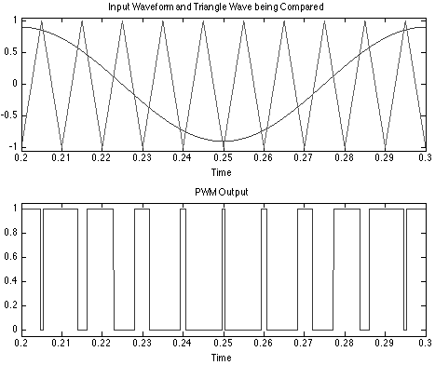

Figure 2: Pulse Width Modulation

* Microcontroller and Sensor Unit

**Sensor Subsystem**: The system uses passive infrared (PIR) sensors to detect motion, with a range of up to 22 feet, and a wide detection area. The ambient photodiode sensor will signal the exterior system during daylight hours, which change regularly. It accomplishes this by measuring light across different colors, with peak sensitivity at 600 nm, corresponding to the color orange.

**Microcontroller Operations**: The microcontroller receives real-time data from both the sensors and the battery system, providing information like battery life and usage. It also communicates with a user app, allowing manual override of system settings to control the lights as needed.

**Power Management**: The microcontroller ecosystem manages power consumption by utilizing different modes, such as operational, idle time, and deep sleep during daylight hours to optimize energy usage.

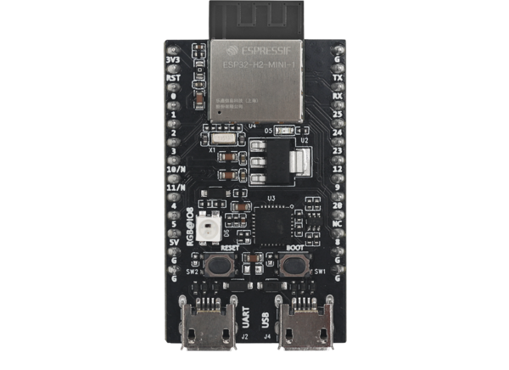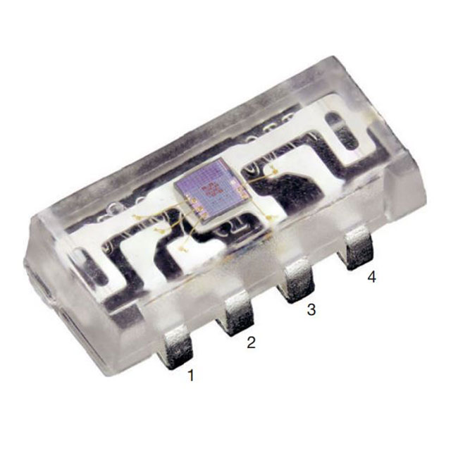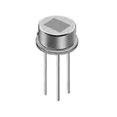

Figure 3: Microcontroller Figure 4: Ambient light sensor Figure 5: Passive Infrared

* Load and Power Inversion

**Subsystem Overview**: The load and power inversion subsystem includes a Buck Converter and an Inverter, providing steady power to the microcontroller and lights.

**Buck Converter**: This connects the battery to the microcontroller, ensuring a constant 5V input. It was chosen for its ability to adjust voltage as the battery depletes, stepping down to maintain the 5V requirement. An additional Buck Converter will be used to step down from the 5V DC output of the first Buck Converter to a 3.3V DC that the light sensor system will operate on.

**Inverter**: The Inverter connects the microcontroller to the porch and foyer lights, taking the 3.3V DC that the microcontroller outputs and converting it to 120V AC that standard residential lightbulbs operate on.

Figure 6: Buck Converter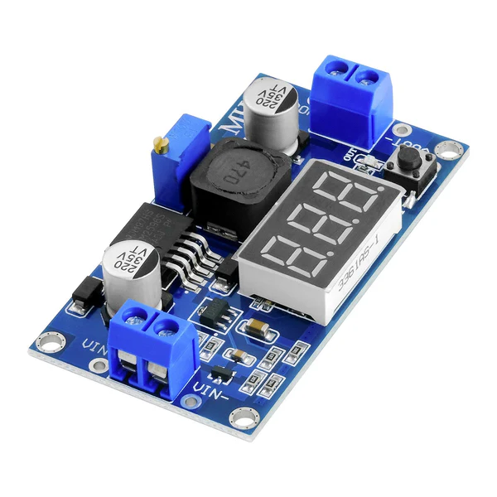

* Mobile App

**Remote Control**: The mobile app enables users to remotely control the automatic solar lighting system. It offers the option to switch from automatic to manual operation.

**System Monitoring**: The app displays real-time statistics such as battery health, solar panel status, and the current light mode. It communicates with the Microcontroller Control Unit via Bluetooth.

**Compatibility**: The app runs natively on Android devices that are operating Android 7.0 or higher.

Figure 7: Mobile App Icon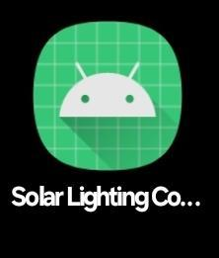

## 3.4 Modes of Operations

There are two modes of operation which are “Automatic” and “Manual” control. These two modes are determined by user choice, as the App provides a toggle between them. During the “Automatic” mode, the ambient and infrared sensors on the porch and the infrared sensor in the foyer completely determine the on/off status of the lights of the home. The Ambient sensor will determine whether it is daytime or nighttime and if it determines that it is nighttime, the infrared sensor will become the determining factor with the lights turning on with 5-7 meter range detection for people. The same infrared sensor will determine the status of the lights inside of the foyer.

During the “manual” mode, which can be toggled to by the app, the sensors and automated parts of the system become negligent. The lights are still completely solar powered and self sustaining, but now require user input to determine their on/off status. This user input is presented in two different ways. The first way is the traditional means of turning lights on and off which is two physical switches that would be installed in the home for the foyer and porch. The second way is by means of the app, which would have separate on and off buttons for the foyer and porch.

## 3.5 Users

The Automatic Solar Lighting System will be marketed towards homeowners and home developers to provide them with an energy efficient lighting system. The self-sustainable energy independent design of the product means that the product can be installed independent of the energy grid of the home, allowing it to be fully modular and easy to install. It also allows for more energy conscious homeowners and developers to have a part of their home that would constantly be running, as a result of the sensors, to use clean energy.

## 3.6 Support

Support for the Automatic solar lighting system is provided by a detailed user manual which provides the user with information for installation, maintenance, suggested additional components and usage. The manual will describe how the system interfaces with the app provided with purchase of the system, however online tech support will also be provided for app debugging and assistance as needed.

# Scenarios

## 4.1 Rolling Blackouts

During times of high demand in Texas, particularly in the summer, ERCOT occasionally implements rolling blackouts. While decisions about the power grid are out of our hands, having an Automatic Solar Lighting System can provide a reliable source of indoor and outdoor lighting during these outages. This system ensures that your lights continue to function smoothly, even when power disruptions occur, offering a practical solution for maintaining lighting without the need for the grid.

## 4.2 General Use-Case

Lights in the porch and foyer of the home can be automated for ease of use by homeowners. Additionally, it will provide a clean energy solution to a portion of their home energy consumption while also keeping electricity bills low by taking some load off of the home power grid through isolated solar power and automated light management so no lights are left on all of the time.

# Analysis

## 5.1 Summary of Proposed Improvements

* This is a solar powered system independent from the home's power grid.
* The system utilizes ambient sensors to determine if there is enough natural light present or if the system needs to be primed for activation.
* The foyer light (indoor) and porch light (outdoor) are activated by motion sensors so that they are not constantly running.
* A mobile app is used for manual control of the lights and to display vital information regarding the lighting system.

## 5.2 Disadvantages and Limitations

* Positioning the motion sensors in order to only detect human presence will be challenging in yielding ~100% accuracy with our proposed system.
* Our system is dependent on flat mounted solar panels, which can vary the charging efficiency depending on weather conditions and what season the location of the system is in.
* Battery life is a limiting factor because of the system not being connected to a secondary source of power. If the battery is unable to charge for an extended period of time or deteriorates then the system will be unable to function at peak performance or for long periods of time.

## 5.3 Alternatives

* Existing grid dependent home lighting system enhanced with sensors and remote controls
* Similar automatic system, but with a wind turbine instead of solar panel. In most residential scenarios, this would be a violation of building code. Only applicable in rural areas.
* Natural gas powered generation. Natural gas is often cheaper than electricity. With the proper power conversion, it is possible, and may be feasible, to power not only your lights but other aspects of your home as well.

## 5.4 Impact

* The system will help reduce light pollution by turning on the lights only when the sensors detect a human presence, the lights will then turn off after a set amount of time with no human detection.
* The system will additionally help reduce cost that is associated with continuously running lights during the night.
* The system will provide a clean energy solution for a portion of their home electricity systems for those that are energy conscious.

Automatic Solar Lighting System

Bakanyildiz, Atahan,

Gilat, Romi,

Maxwell, Cedar,

Miller, Nick

**Functional System Requirements**

REVISION – 1

26 September 2024

Functional System Requirements

for

Automatic Solar Lighting System

Team <04>

Approved by:

_____________________________

Project Leader Date

_____________________________

Prof. Lusher Date

_____________________________

T/A Date

**Change Record**

| **Rev.** | **Date** | **Originator** | **Approvals** | **Description** |
| --- | --- | --- | --- | --- |
| **0** | 09/26/2024 | Automatic Solar Lighting System |  | Draft Release |
| **1** | 09/26/2024 | Automatic Solar Lighting System |  | Revision 1 |

**Table of Contents**

**List of Tables** **17**

**List of Figures** **18**

**1. Introduction** **19**

1.1 Purpose and Scope 19

1.2 Responsibility and Change Authority 19

**2. Applicable and Reference Documents** **20**

2.1 Applicable Documents 20

2.2 Reference Documents 20

2.3 Order of Precedence 21

**3. Requirements** **21**

3.1 System Definition 21

3.2 Characteristics 22

**4. Support Requirements** **25**

Appendix A Acronyms and Abbreviations 27

Appendix B Definition of Terms 28

Appendix C Interface Control Documents 28

## List of Tables

Table 1: Subsystem Leads………….....……………………………………………….20

Table 2: Applicable Documents……………………………………………..………….20

Table 3: Reference Documents……………………………………………..………….20

## 

## 

## 

## 

## 

## 

## 

## 

## 

## 

## 

## 

## 

## 

## List of Figures

Figure 1: Project Concept Diagram………………………….……………………...…19

Figure 2: Automatic Solar Lighting System Block Diagram…………………………21

# Introduction

## 1.1 Purpose and Scope

The Automatic Solar Lighting System (the “System”) provides an elegant solution to your indoor and outdoor lighting needs. Using motion sensors for your home’s interior and ambient light sensors for your porch, the System automatically raises and lowers the lights when appropriate; no effort required. Accompanying this is an app which provides for manual operation of the System as well as various statistics pertinent to the System’s usage and operation. The power of the sun allows the System to operate independently during the day, all while charging a battery to allow continuous operation throughout the night. The System utilizes solar power, which does not raise your utility bill, on the contrary, it lowers it. This system operates completely independently of your current grid controlled home electric system. It is a model for what the future may look like as photovoltaic technology continues to rapidly develop, if the past two decades are any indication.

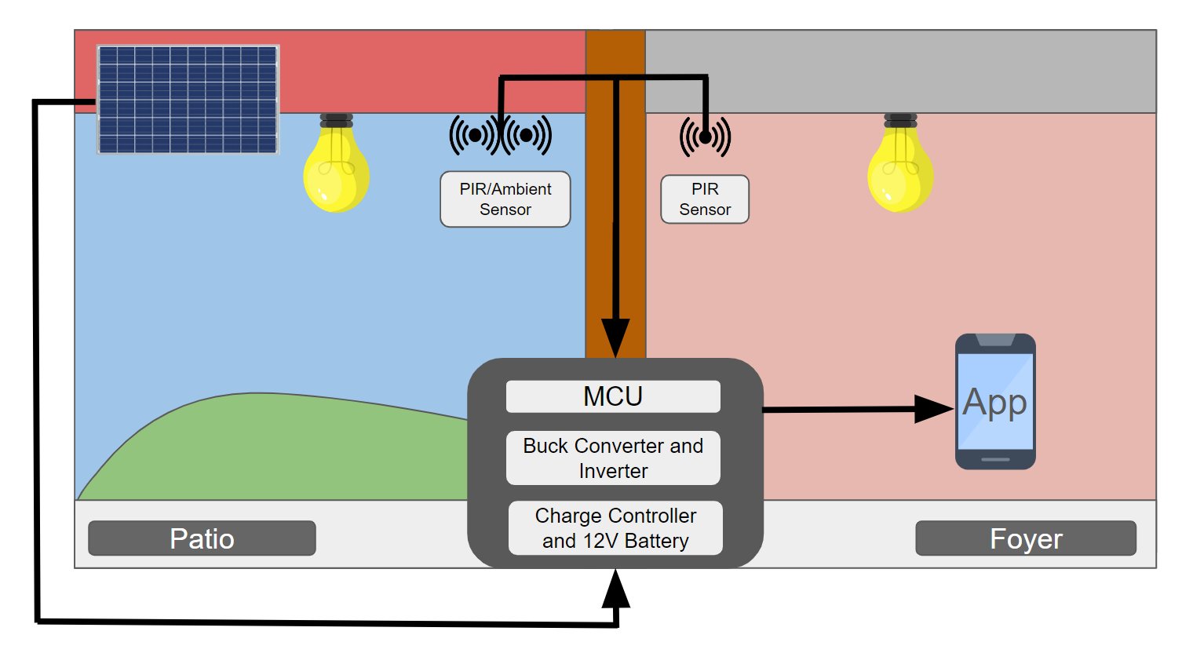

Figure 1: Project Concept Diagram

## 1.2 Responsibility and Change Authority

The team leader, Romi Gilat, will be responsible for verifying all requirements of the project are met. These requirements can only be changed with the approval of the team leader and Professor John Lusher.

| **Subsystem** | **Responsibility** |
| --- | --- |
| Power Generation | Atahan Bakanyildiz |
| Microcontroller & Sensor Unit | Romi Gilat |
| App | Cedar Maxwell |
| Buck Converter / Inverter | Nick Miller |

Table 1: Subsystem Leads

# Applicable and Reference Documents

## 2.1 Applicable Documents

| Document Number | Revision/Release Date | Document Title |
| --- | --- | --- |
| DSE-CN3768 | 2015 | CN3768 Design Specifications Sheet |
| ADP 1853-1503396 | Revision A - 2/2017 | ADP1853 Data Sheet |

Table 2: Applicable Documents

## 2.2 Reference Documents

| Document Number | Revision/Release Date | Document Title |
| --- | --- | --- |
| NFPA 70 | December 28, 2021 | National Electrical Code |
| IEC 61427 | 1999 | Secondary cells and batteries for solar  photovoltaic energy systems |
| IEEE 802.15.3 | September 21, 2023 | IEEE Standard for Wireless  Multimedia Networks |

Table 3: Reference Documents

## 2.3 Order of Precedence

In the event of a conflict between the text of this specification and an applicable document cited herein, the text of this specification takes precedence without any exceptions. All specifications, standards, exhibits, drawings or other documents that are invoked as “applicable” in this specification are incorporated as cited. All documents that are referred to within an applicable document are for guidance and information only, apart from ICD’s that have their applicable documents considered to be incorporated as cited.

# Requirements

## 3.1 System Definition

The automatic solar lighting system will provide a clean energy, energy efficient, and automated for ease-of-use alternative to conventional foyer and porch lighting for one’s home. The solar generated system will have sensors that detect when the lights need to be turned on and off. The porch system will have ambient sensors that make sure that lights don’t turn on when it is day time and is only able to turn on when it is dark outside. Additionally, it will only turn on when there are people entering the porch area through the use of an infrared sensor. This same infrared sensor will also be the way that the foyer lighting activates during automation. The user is provided with an app that not only gives them data on the generation aspect of the system but it will allow the user to turn the lights off and on manually, overwriting the automation system, as well as turning the automation component off completely.



Figure 2: Automatic Solar Lighting System Block Diagram

## 3.2 Characteristics

### 3.2.1 Functional / Performance Requirements

### 3.2.1.1 Standby Wake-Up Miss Rate

The maximum number of miss trigger incidents within the sensor's field of view will be 15% or less.

*Rationale: The PIR sensors individually have a 85% field of view. With the implementation of two sensors to increase the field of view, the only areas that aren’t within the field of view are right alongside the wall where the sensor will be installed. To combat daytime activation, the system will be programmed to not activate during daylight hours, which will be dynamic to include daylight saving time.*

### 3.2.1.2 False Positive Rate

Within the sensor system, the false positive rate will be less than 15% in case of small animals or critters walking within the range.

*Rationale: To prevent small animals or outside critters from triggering the system, the sensors will be placed higher up to exclude such small animals from its line of sight. This prevents the waste of power within the system with false positives.*

### 3.2.1.3 Battery Operating Time

The operating time of the 12V Lead-Acid battery shall be between 10 and 20 hours.

*Rationale: The 12V Lead-Acid battery that we chose to implement in our system is rated to last for 20 hours, this is ideal because we want our system to be running through the duration of the night/when it gets dark outside.*

**3.2.1.4 Solar charging time**

The solar charging time shall be between 4 and 6 hours.

*Rationale: In central Texas, during the summer, there is peak sunlight for solar charging for about 6 hours a day. This goes down to about 4 hours during the winters in the worst case scenario. Taking the average of this, we can expect about 5 hours of peak charging regularly and about 5 hours of standard charging per day. This in accordance with the 10-20 hours of consumption from the 12V battery, means that there should be no days where the battery is drained, meaning that the consistent charge through the day can be upheld.*

**3.2.2 Physical Characteristics**

The automatic solar lighting system will have solar panels attached to the rooftop, external lead acid 12 volt batteries, internal wall wires to connect the different components, two sensor systems, a charge controller, and a microcontroller unit. The control unit will be composed of the microcontroller, buck inverter, and charge controller. The batteries will be connected to both the solar unit and control center, which will feed into the two sensor subsystems.

**3.2.2.1 System Area**

The system area shall include the rooftop, foyer and exterior of a household.

*Rationale: These places encompass the requirements for this project.*

**3.2.2.2 Installation**

The solar panel installation will be done up to National Electrical Code (NEC), International Building Code (IBC), and International Fire Code (IFC), along with the mounting of the system 45 degrees tilted offset from the ground level for optimal sunlight. The batteries will be done to NEC and be placed within the wall close to the control unit. The control unit will be placed within the wall as well, with wiring connecting the exterior and interior sensor units. These will be mounted on the ceiling to ensure optimal field of view.

*Rationale: Our team desired to create the system in a neat and compact manner while still upholding codes to ensure a safe product.*

**3.2.2.3 Mounting**

The automatic solar lighting system will consist of three primary mounted components: solar panels, an indoor sensor with integrated light bulbs, and an outdoor sensor with integrated light bulbs. The interior and exterior lighting units are designed to be relatively lightweight, eliminating the need for substantial structural support, such as interior beams, for installation. Meanwhile, the solar panels will be strategically positioned on the roof to maximize exposure to sunlight.

**3.2.3 Electrical Characteristics**

**3.2.3.1 Inputs**

The Automatic Solar Lighting System is designed to receive multiple inputs across its different subsystems. The Power Generation subsystem solar power input via the photovoltaic panels. The app receives information on the status of the light as well as various status updates for each of the included subsystems and their performance. The Buck Converter/Inverter subsystem intakes a certain DC voltage and transforms it into a voltage that is suitable for usage with the MCU or the lighting.

**3.2.3.1.1 Power Consumption**

The system shall consume approximately 18 Watts, 9 Watts per light bulbs.

*Rationale: Our system will implement a pair of 60 Watt rated LED light bulbs which utilize 9 Watts each.*

**3.2.3.1.2 Input Voltage Level**

The input voltage level shall be +10 VDC to +14 VDC.

*Rationale: The voltage of the fully charged lead-acid battery will differ slightly from its nominal value of 12V. The capacity of the battery will decrease slightly throughout the duration of storage.*

**3.2.3.1.3 External Commands**

The Automatic Solar Lighting System shall document all external commands in the appropriate ICD.

**3.2.3.2 Outputs**

**3.2.3.2.1 Data Output**

The Automatic Solar Lighting System will output the status of the porch and foyer lights by means of the mobile application.

*Rationale: This provides a modern and easy to understand user interface for potential customers.*

**3.2.3.2.2 Diagnostic Output**

The MCU will transmit diagnostic data to the app for display.

*Rationale: This will provide the ability for debugging any issues which may arise without having to connect a computer to the MCU.*

**3.2.3.2.3 Connectors**

The Automatic Solar Lighting System will use the American National Standard for Electrical Connectors ANSI C119.6-2011.

*Rationale: System conforms to connector standard.*

**3.2.3.2.4 Wiring**

The Automatic Solar Lighting System will follow the guidelines set forth by the National Electrical Code regarding electrical wiring. The standard applications of electrical systems is in the article NFPA 70 (NEC).

*Rationale: System conforms to wiring standard.*

**3.2.4 Environmental Requirements**

The Automatic Solar Lighting System shall be designed for residential usage and shall operate under the conditions described in the following sections. The system is reliant on solar power, therefore placing the system in a high solar environment, such as Texas, is optimal.

**3.2.4.1 Altitude**

The Automatic Solar Lighting System shall be able to operate efficiently at altitudes around 300 feet.

*Rationale: System design in College Station takes place at 289 feet, which will be the basis of operation for the Automatic Solar Lighting System.*

**3.2.4.2 Thermal**

The Automatic Solar Lighting System shall be able to operate efficiently at temperatures ranging from 0℃ to 70℃. The microcontroller unit will be located indoors, where the temperature is expected to range from 0°C to 70°C. The sensor system will be used both indoors and outdoors, and is rated for temperatures from -40°C to 85°C.

*Rationale:These components were specifically chosen to withstand the hot Texas summers and cold desert winters.*

**3.2.4.3 Humidity**

The sensor unit will function up to 90% humidity for proper functioning.The sensors themselves need to be placed in a water proof, sealed container that will prevent the electronics from getting drenched.

*Rationale: The average humidity in Texas is about 90%.*

# Support Requirements

The Automatic Solar Lighting System will require proper solar power regulation, as well as voltage power regulation within the interior power system. The system will also allow Bluetooth connection to maintain control over the lighting system through the app. One automatic solar lighting system will consist of (1) solar panels, (1) lead acid 12V batteries, (1) interior sensor, (1) exterior sensor, (1) microcontroller unit, (1) app to be downloaded on a mobile phone.

Appendix A Acronyms and Abbreviations

mA Milliamps

mW Milliwatts

g Grams

TBD To Be Determined

MCU Microcontroller Unit

V Volts

VDC DC Voltage

PCB Printed Circuit Board

IEEE Institute of Electrical and Electronics Engineers

PIR Passive Infrared Sensor

LED Light Emitting Diode

NFPA National Fire Protection Association

NEC National Electrical Code

IBC International Building Code  
 IFC International Fire Code

ANSI American National Standards Institute

Interface Control Document

for

Automatic Solar Lighting System

Team <04>

Approved by:

_____________________________

Project Leader Date

_____________________________

Prof. Lusher Date

_____________________________

T/A Date

**Change Record**

| **Rev.** | **Date** | **Originator** | **Approvals** | **Description** |
| --- | --- | --- | --- | --- |
| **0** | 09/20/2024 | Automatic Solar Lighting System |  | Draft Release |
| **1** | 09/26/2024 | Automatic Solar Lighting System |  | Revision 1 |

**Table of Contents**

**List of Tables** **....................................................................................................... 31** **List of Figures** **..................................................................................................... 32** **1. Overview** **.......................................................................................................... 33**

**2. Reference and Definitions** **......................................................................................... 33**

**2.1. References** **.............................................................................................. 33** **2.2. Definitions** **............................................................................................... 33**

**3. Physical Interface****............................................................................................ 33**

**3.1. Weight...................................................................................................... 33**

**3.1.1. Microcontroller Unit****........................................................................ 33**

**3.1.2. Generation Subsystem................................................................... 33**

**3.1.3. Inverter Subsystem****......................................................................... 34**

**3.1.4. Sensor Subsystem****.......................................................................... 34**

**3.2. Dimensions** **............................................................................................ 35**

**3.2.1. Dimensions of Generation Subsystem** **......................................... 35**

**3.2.2. Dimensions of Microcontroller Sensor Subsystem** **..................... 35**

**3.3. Mounting Locations** **.............................................................................. 35**

**4. Solar Interface** **................................................................................................. 36** **5. Electrical Interface** **.......................................................................................... 36** **5.1. Primary Input Power** **.............................................................................. 37** **5.1.1. Microcontroller Unit** **........................................................................ 37**

**5.1.2. Sensor Unit....................................................................................... 37**

**5.2. Voltage and Current Levels** **.................................................................. 37**

**5.2.1. Maximum Values ............................................................................. 37**

**5.2.2. Stand-by Values** **.............................................................................. 37**

**5.3. Signal Interfaces** **................................................................................... 38**

**5.3.1. Signal Interface Module****.................................................................. 38**

**5.4. User Control Interface** **.......................................................................... 38**

**6. Communications / Device Interface Protocols** **............................................ 38**

**6.1. Wireless Communications ................................................................... 38** **6.1.1. Wi-Fi** **................................................................................................. 38**

**6.1.2. Bluetooth ......................................................................................... 38**

**6.2. Device Peripheral Interface** **.................................................................. 38**

## List of Tables

Table 1: Microcontroller Subsystem Weight ...………………………………………. 34

Table 2: Generation Subsystem Weight ………………………...…………………... 35

Table 3: Inverter Subsystem Weight …………………………………………………. 35

Table 4: Exterior subsystem weight ………………………………………………….. 35

Table 5: Interior subsystem weight …………………………………………………... 35

Table 6: Generation Subsystem Dimensions ……………………………………….. 36

Table 7: Microcontroller and Sensor Subsystem Dimensions …………………….. 36

Table 8: Maximum Voltage and Current Levels ..…………………………………….38

Table 9: Stand-by Voltage and Current Levels .…………………………..………… 38

## List of Figures

Figure 1: Electrical Interface Diagram………………………………………………... 37

# Overview

This document is included to provide concise details on how the various subsystems interact with each other. Information such as inputs, outputs, dimensions, and how the subsystems interface will be listed within this document. First, the inputs for individual subsystems will be listed, accompanied by maximum electrical values for each component. Finally, the interface will be laid out in its entirety to

# References and Definitions

## 2.1 References

Refer to section 2.2 on the Functional System Requirements document.

## 2.2 Definitions

mA Milliamp

mW Milliwatt

g Gram

MHz Megahertz

TBD To Be Determined

MCU Microcontroller Unit

ASLS Automatic Solar Lighting System

PIR Passive Infrared Sensor

LED Light Emitting Diode

PCB Printed Circuit Board

# Physical interference

## 3.1 Weight

### 3.1.1 Microcontroller Unit

Total weight: 3.14 g

Total weight including PCB: 35 g

| **Component** | **Weight** | **Number of Items** | **Total weight** |
| --- | --- | --- | --- |
| ESP 32 | 3 g | 1 | 3 g |
| MAX485ESA | 0.07 g | 2 | 0.14 g |

Table 1: Microcontroller Subsystem Weight

### 3.1.2 Generation Subsystem

| **Component** | **Weight** | **Number of Items** | **Total Weight** |
| --- | --- | --- | --- |
| ML5-12F2 12V Lead-Acid Battery | 1401.60 g | 1 | 1401.6 g |
| NPA100-12H Solar Panel | 6894.60 g | 1 | 6894.60 g |

Table 2: Generation Subsystem Weight

### 3.1.3 Inverter Subsystem

| **Component** | **Weight** | **Number of Items** | **Total Weight** |
| --- | --- | --- | --- |
| ADP1853ACPZ-R7 | 0.037g | 2 | 0.074g |
| IAUCN10S7N021ATMA1 | TBD | 4 | TBD |

Table 3: Inverter Subsystem Weight

### 3.1.4 Sensor Subsystem

Exterior System

The total weight of the exterior system will be 0.79 grams

| **Component** | **Weight** | **Number of Items** | **Total Weight** |
| --- | --- | --- | --- |
| VEML 7700 | 0.5 g | 1 | 0.5 g |
| IRA-S210ST01 | 0.2 g | 1 | 0.2 g |
| THVD1410DR | 0.08 g | 1 | 0.08 g |
| PIC24H64GP502-I/SO | 0.01 g | 1 | 0.01 g |

Table 4: Exterior subsystem weight

Interior System:

The total weight of the inter system will be 0.49 grams

| **Component** | **Weight** | **Number of Items** | **Total Weight** |
| --- | --- | --- | --- |
| IRA-S210ST01 | 0.2 g | 2 | 0.4 g |
| THVD1410DR | 0.08 g | 1 | 0.08 g |
| PIC24H64GP502-I/SO | 0.01 g | 1 | 0.01 g |

Table 5: Interior subsystem weight

## 3.2 Dimensions

### 3.2.1 Dimensions of Generation Subsystem

| **Component** | **Length** | **Width** | **Height** |
| --- | --- | --- | --- |
| Charge Controller PCB | TBD | TBD | TBD |
| ML5-12F2 12V Lead-Acid Battery | 8.89 cm | 6.80 cm | 10.61 cm |
| NPA100-12H Solar Panel | 91.01 cm | 67.48 cm | 2.99 cm |

Table 6: Generation Subsystem Dimensions

### 3.2.2 Dimensions of Microcontroller and Sensor Subsystem

All of these system dimensions will include PBC and housing dimensions.

| **Device** | **Length** | **Width** | **Height** |
| --- | --- | --- | --- |
| Microcontroller | 70 mm | 70 mm | 30 mm |
| Exterior sensor | 70 mm | 70 mm | 30 mm |
| Interior sensor | 40 mm | 40 mm | 15 mm |

Table 7: Microcontroller and Sensor Subsystem Dimensions

This does not include the RS-485 connection wires, which connect the microcontroller to the two sensor units, as well as the ground and power wires.

## 3.3 Mounting Locations

The Automatic Solar Lighting System will be installed in the foyer and outside near the entrance, providing automated lighting as individuals pass through these areas. The interior lighting will operate for several hours after dusk, enhancing visibility to prevent tripping and falling, and facilitating safe entry into the household. The exterior lighting system will serve as both a deterrent to potential intruders and a source of illumination during nighttime hours.

# Solar Interface

The solar panel and 12V battery are both connected to a PCB which will run as a solar power charge controller. The solar panel will give out a voltage that goes through a charge controller into a 12V battery. There is a LED on the charge controller that provides direct information on the state of charging that can’t be understood from app information. If the LED is on then this states that the device is in trickle charging mode, constant current pull, or over-charge mode. If the LED is off, this means that either the charging is in float mode, the input voltage is lower than the UVLO level, or the input voltage is lower than the battery voltage. The last case would mean that there is not sufficient power supplied from the solar panel to actually charge the battery.

# Electrical Interface

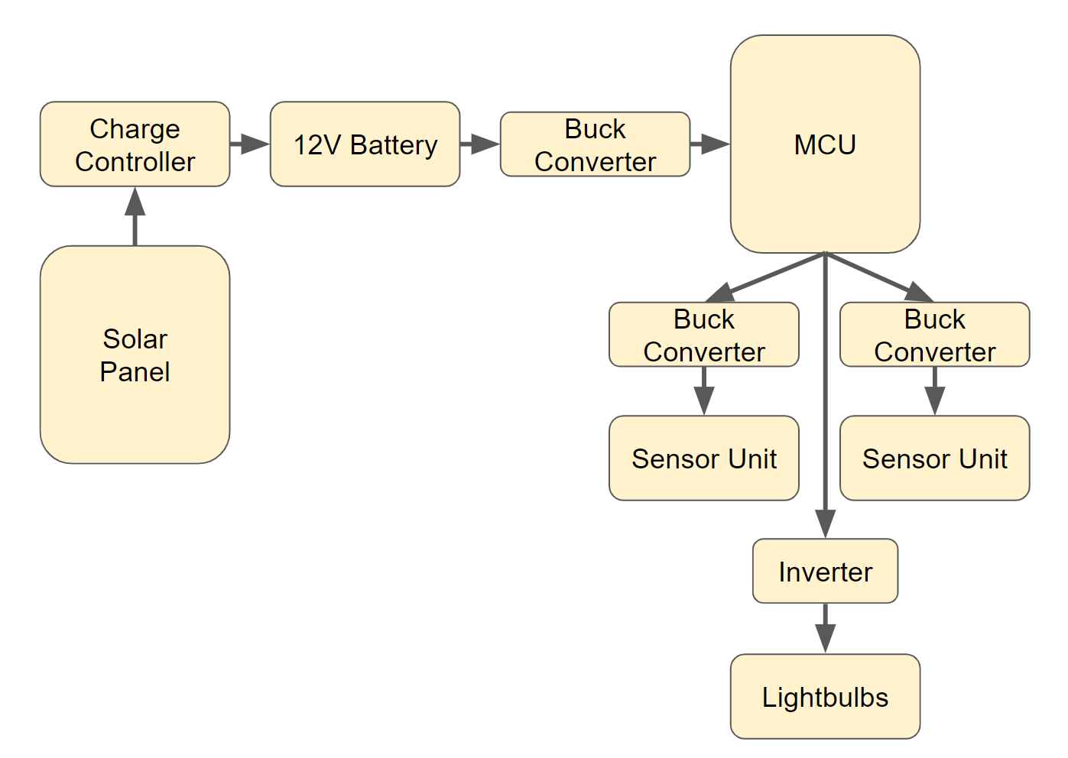

Figure 1: Electrical Interface Diagram

## 5.1 Primary Input Power

### 5.1.1 Microcontroller Unit

The microcontroller unit will run at 5 volts power that will be supplied by the battery system.

*Rationale: The design specifications for the selected Microcontroller Unit requires a steady DC voltage input of 5V.*

### 5.1.2 Sensor Unit

The two sensor units will run at 3.3 volts, both supplied by the battery system.

*Rationale: The design specifications for the selected Sensor Units requires a steady DC voltage input of 3.3V.*

## 5.2 Voltage and Current Levels

### 5.2.1 Maximum Values

| Component | Voltage [V] | Current [A] | Power [mW] |
| --- | --- | --- | --- |
| ADP1853 | 21.00 | 25.000 | TBD |
| ESP32-S2 | 3.60 | 1.800 | 89.13 |
| NPA100-12H | 20.23 | 6.250 | 100000.00 |

Table 8: Maximum Voltage and Current Levels

### 5.2.2 Stand-by Values

| Component | Voltage [V] | Current [mA] | Power [mW] |
| --- | --- | --- | --- |
| NPA100-12H | 17.00 | 5890.00 | 100000.00 |
| ESP32-S2 | 3.30 | 500.00 | TBD |

Table 9: Stand-by Voltage and Current Levels

## 5.3 Signal Interfaces

### 5.3.1 Signal interface module

The PIR sensor will be tested using an IR LED, allowing for localized testing within a small environment. The distance will be gradually increased to determine the size of objects that can be detected and the amount of heat required for activation. The ambient light sensor will be evaluated at various times of the day, particularly during dusk and dawn, to observe when the signal is triggered. These tests will provide valuable data for calibrating the exterior sensors, such as adjusting the automatic solar lighting system's activation times during daylight hours. Additionally, they will help determine whether small animals, such as dogs or cats, will trigger the system.

## 5.4 User Control Interface

The User Control Interface will be concentrated in the App subsystem. The mobile app will allow the user to manually control the app should he desire, as well as displaying data such as battery level, solar panel status and current sensor status.

# Communication / Device Interface Protocols

## 6.1 Wireless communication

### 6.1.1 Wi-Fi

The MCU will contain Wi-Fi capabilities within the IEEE 802.11 guidelines. The app will be a web based application, which will be able to connect to the automatic solar light system’s MCU remotely if necessary. The information provided by the MCU will be battery voltage, PV panel statues, if the lights are activated.

### 6.1.2 Bluetooth

The MCU will communicate with the app on the user’s smartphone via Bluetooth. Information such as battery voltage, PV panel status and light state will be provided to and displayed by the app. In turn, the app will be able to display this data in a friendly manner as well as being able to issue commands back to the MCU, such as manually turning off the lights.

## 6.2 Device Peripheral Interface

The MCU unit will connect to the app using a Bluetooth connection, as well as using UART to communicate with the two sensors in the system.

Automatic Solar Lighting System

Bakanyildiz, Atahan,

Gilat, Romi,

Maxwell, Cedar,

Miller, Nick

**Schedule and Validation**

REVISION – 1

26 September 2024

Schedule:

| Work | End Date | Owner | Status | Date Completed |
| --- | --- | --- | --- | --- |
| Concept of Operations | 9/15/2024 | All | Complete |  |
| Functional System Requirements | 9/26/2024 | All | Revision 1 |  |
| Interface Control Document | 9/26/2024 | All | Revision 1 |  |
| Project Parts Ordered | 10/01/2024 | All | Revision 1 |  |
| Midterm Presentation  Project Introduction | 10/02/2024 | All |  |  |
| Subsystem Circuit Design | 9/24/2024 | Romi, Atahan, Nick |  |  |
| Complete introduction assignments and hello world | 10/2/2024 | All |  |  |
| Learn App Coding | 9/24/2024 | Cedar |  |  |
| Pseudocode Subsystem Design | 9/24/2024 | All |  |  |
| Generation LTSpice Simulations | 9/24/2024 | Atahan |  |  |
| Progress Update 1 | 10/9/2024 |  |  |  |
| Progress on Bluetooth within app | 10/1/2024 | Cedar |  |  |
| Design PCB for Buck converters | 10/2/2024 | Nick |  |  |
| Breadboard test for Buck converters | 10/8/2024 | Nick |  |  |
| Generation schematic level design for PCB | 10/2/2024 | Atahan |  |  |
| Generation “to be ordered” parts list created | 10/2/2024 | Atahan |  |  |
| Generation parts ordered | 10/02/2024 | Atahan |  |  |
| Breadboard test microcontroller | 10/8/2024 | Romi |  |  |
| Breadboard test sensor unit to ensure communication | 10/8/2024 | Romi |  |  |
| Work on project presentation 2 | 10/22/2024 | All |  |  |
| Progress Update 2  Project Presentation 2 | 10/23/2024 |  |  |  |
| Solar charge controller built using breadboards | 10/23/2024 | Atahan |  |  |
| Solar Panel and Battery tested with off the shelf charge controller | 10/15/2024 | Atahan |  |  |
| Design PCB for solar power charge controller | 10/9/2024 | Atahan |  |  |
| Configuration complete between MCU and sensors | 10/15/2024 | Romi |  |  |
| Design PCB for MCU, interior and exterior sensors | 10/23/2024 | Romi |  |  |
| Design PCB for Inverter | 10/23/2024 | Nick |  |  |
| Breadboard test for Inverter | 10/23/2024 | Nick |  |  |
| App UI Complete | 10/23/2024 | Cedar |  |  |
| Sub-System Introduction Project | 10/20/2024 |  |  |  |
| Completed sub-system assignment | 10/20/2024 | All |  |  |
| Progress Update 3 | 10/30/2024 |  |  |  |
| Validate and test PCB design with components | 10/30/2024 | Romi |  |  |
| Configuration between MCU and application | 10/30/2024 | Romi |  |  |
| Solar charge controller breadboard design tested with panel and battery | 10/30/2024 | Atahan |  |  |
| Solar charge controller PCB assembled | 10/30/2024 | Atahan |  |  |
| Progress Update 4 | 11/13/2024 |  |  |  |
| Solar charge controller PCB tested with panel and battery | 11/07/2024 | Atahan |  |  |
| Verification of sensor system to trigger with 25 feet | 11/12/2024 | Romi |  |  |
| Validate communication between MCU and App | 11/12/2024 | Cedar,  Romi |  |  |
| App Complete | 11/13/2024 | Cedar |  |  |
| Work on final presentation | 11/15/2024 | All |  |  |
| Final validation complete of all subsystems | 11/17/2024 | All |  |  |
| Finish final presentation preparations | 11/18/2024 | All |  |  |
| Work on report | 11/25/2024 | All |  |  |
| Final Presentation | 11/20/2024 |  |  |  |
| Present as a team | 11/18/2024 | All |  |  |
| Prepare for final presentation | 11/19/2024 | All |  |  |
| Final Demo | 11/26/2024 |  |  |  |
| Present final demos of individual subsystems | 11/26/2024 | All |  |  |
| Final Report | 12/05/2024 |  |  |  |

Table 1: Automatic Solar Lighting System Schedule

Validation Plan:

| Task | Specification | Result | Owner |
| --- | --- | --- | --- |
| Solar Power Supply (max) | Solar Panel gives out 17-20V during peak sunlight hours |  | Atahan |
| Sensor Read Distance | Test the sensor system at 5, 10, 15, 20 and 25 feet. |  | Romi |
| Sensor triggers light | Test sensor system with small critters to manage false triggering. |  | Romi |
| MCU communication with App | The microcontroller needs to communicate with the app. Triggering lights during daylight, |  | Romi, Cedar |
| App displays received data | All UI is completed to display the data received from the MCU correctly |  | Cedar |
| App sends commands | App is able to successfully toggle on and off the lights. |  | Cedar |
| Battery Voltage is stepped down for MCU | The battery will have a 12V output that will go through a Buck Converter to step the Voltage down to 3.3V to abide by the MCU Voltage rating. |  | Nick |
| Battery Voltage is stepped down for Sensor system | The battery will have a 12V output that will go through a Buck Converter to step the Voltage down to 3.3V to abide by the sensor Voltage rating. |  | Nick |
| DC Voltage is converted to AC Voltage for light bulbs | DC Voltage will go through an Inverter for the light bulbs. |  | Nick |

Table 2: Automatic Solar Lighting System Validation

Subsystem Report

for

Automatic Solar Lighting System

Team <04>

Approved by:

_____________________________

Project Leader Date

_____________________________

Prof. Lusher Date

_____________________________

T/A Date

**Change Record**

| **Rev.** | **Date** | **Originator** | **Approvals** | **Description** |
| --- | --- | --- | --- | --- |
| **0** | 09/20/2024 | Automatic Solar Lighting System |  |  |
|  |  |  |  |  |

**Table of Contents**

**List of Tables ....................................................................................................... 31 List of Figures ..................................................................................................... 32**

1. **Introduction………………………………………………………………………………………X**
2. **Microcontroller and Sensors Subsystem Report…………………………………X**
3. **Power Generation Subsystem Report………………………………………………..X**
   1. asjdnlksfdjgldsf………………………………………………………………………………..X
4. **Power Distribution Subsystem Report……………………………………………..X**
5. **App and Database Subsystem Report………………………………………………..X**

## List of Tables

Table 1: dfljghdfkjgf………………………………………………………………………………………………..X

## 

## List of Figures

Figure 1: Electrical Interface Diagram………………………………………………... 37

# Introduction

# Microcontroller and Sensors Subsystem Report

# Power Generation Subsystem Report

# Power Distribution Subsystem Report

# App and Database Subsystem Report

# 